Software Requirement Specifications
Project Title: Mobile Sales Management System
(Tech wave)


Submitted by:
Muhammad Numan
Roll No:
S25BINFT7M04016
Semester:
7th(1M)
Submitted to:
Prof:Abdul karim nawaz

Department of Information Technology
Faculty of Computing
The Islamia University of Bahawalpur

Meeting Details
Sr No | Details | Date | Supervisor Signature
1 | Discussion of project idea and topic selection | 01-03-2026
2 | Approval of project title (Mobile Sales Management System – Tech Wave) | 27-03-2026
3 | Requirement gathering and proposal discussion | 01-04-2026
4 | SRS structure and documentation guidance | 10-04-2026
5 | Review of functional requirements | 14-04-2026
6 | Review of diagrams (DFD, ER, Use Case) | 18-04-2026
7 | Final SRS review and corrections | 27-04-2026
Summary
Here the author will write summery of the document. They can provide a brief of the background, their findings and requirement.

Table of Contents
1. Introduction 4
1.1. Purpose 4
1.2. Scope 5
1.3. Product Perspective 5
1.4. User Characteristics 7
1.5. Similar apps and systems/Literature Review 8
1.6. Proposed Technologies 8
2. Requirements 9
2.1. Function Requirements 9
2.1.1. Sign Up 9
2.2. Non-Functional Requirements 9
3. Use Cases and Flow of Processes 11
3.1. Use Case 1 13

- Introduction:
The Mobile Sales Management System (Tech Wave) is an online platform developed to simplify the process of buying and selling mobile phones. In current market conditions, many small businesses rely on manual processes or social media platforms, which are not efficient, secure, or well organized.
This system provides a structured solution where customers can browse mobile phones, compare features, and place orders easily. At the same time, administrators can manage products, customers, and orders through a centralized system.
The system aims to improve efficiency, reduce manual work, and enhance customer experience.
The Mobile Sales Management System is designed as a digital solution for mobile shops. It allows customers to interact with the system through a user-friendly interface, while the admin controls all operations from the backend.
The system solves problems such as:
- Poor product management
- Lack of order tracking
- Limited customer reach
- Manual errors
  - Purpose:
The main purpose of this system is:
- To provide a digital platform for mobile selling
- To reduce manual workload for shop owners
- To provide fast and easy access for customers
- To maintain secure and organized data

  - Scope:
  - Include:
- User account management
- Product listing and browsing
- Search and filtering
- Shopping cart system
- Order processing
- Admin dashboard

Not Include:
- Online payment gateway (future work)
- Delivery tracking system
- Multi-vendor support

  - Product Perspective:
This system is a 3-tier architecture system:
- Presentation Layer (Frontend)
  - User interface (HTML, CSS, JS)
- Application Layer (Backend)
  - Business logic (PHP)
- Data Layer (Database)
  - MySQL database

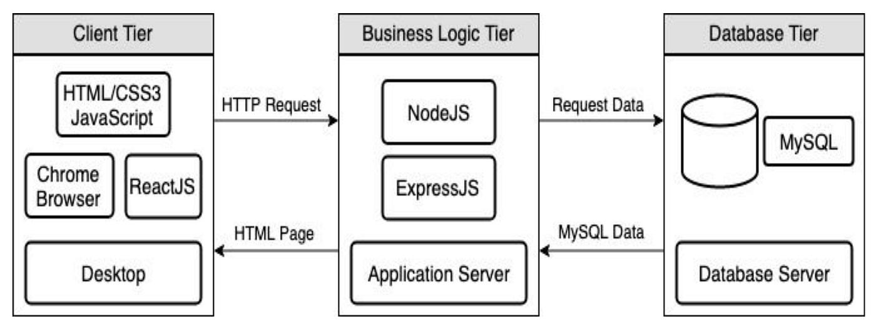

Diagram: 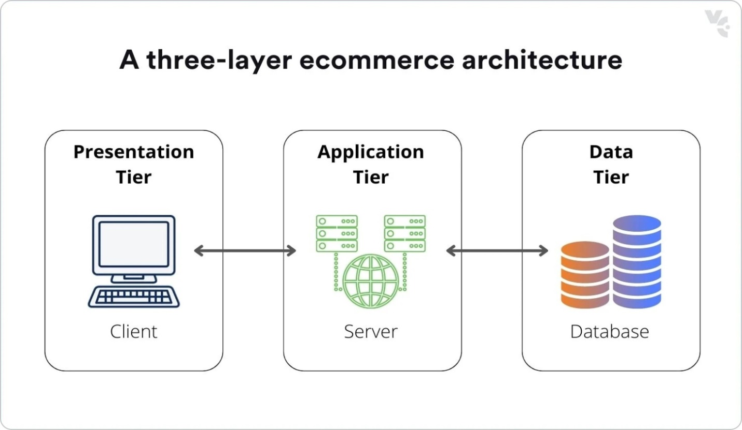

  - User Characteristics:

Customer:
- Basic smartphone user
- No technical knowledge required
- Uses system for browsing and purchasing

Admin
- Basic IT knowledge
- Responsible for managing system data
- Can handle product updates and orders

Diagram are as follow:

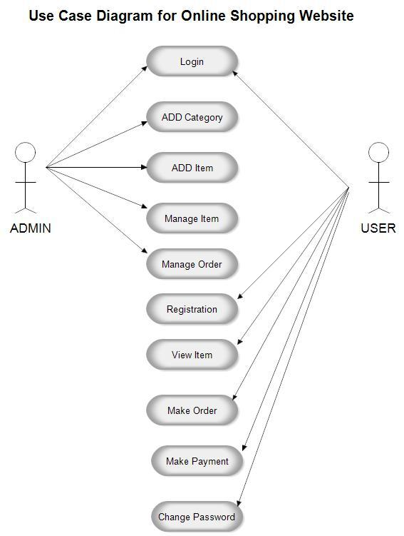

  - Similar apps and systems/Literature Review:
- Existing System
- Daraz→ Large platform but complex
- Amazone→ Powerful but not suitable for small businesses
- OLX→ No structured product management

2.Problem in Exisiting System:
- Difficult navigation
- Lack of focus on mobile products
- Not suitable for small shop owners
- Improvement in our System:
- Simple interface
- Mobile-focused platform
- Easy management for admin
  - Proposed Technologies:
Component | Technology
Frontend | HTML, CSS, JavaScript
Backend | PHP
Database | MySQL
Tools | VS Code, GitHub

- Requirements:

The system provides complete functionality for mobile selling. Users can register, log in, browse mobile phones, and place orders. The system stores all information in a database and allows admin to manage products and orders efficiently.
  - Function Requirements
The requirement format as following.

Sign Up
- Purpose: Create new account
- Users: Customer
Input:
- Name
- Email
- Password (min 8 characters)
- Phone number
Processing:
- Validate input
- Store data in database
Output:
- Account created

2.1.2 Login (FR002)
- Validate user credentials
- Allow access to system

2.1.3 Product Browsing (FR003)
- Display mobile list
- Show details like price, brand, features

2.1.4 Search & Filter (FR004)
- Search by keyword
- Filter by price or brand

2.1.5 Add to Cart (FR005)
- Store selected products temporarily

2.1.6 Place Order (FR006)
- Confirm order
- Store order in database

2.1.7 Manage Products (FR007)
- Admin adds new products
- Updates product details
- Deletes products

2.1.8 Manage Orders (FR008)
- Admin views orders
- Updates order status
  - Non-Functional Requirements:

Performance
- System response time < 3 seconds

Security
- Password encryption
- Secure login system

Usability
- Easy navigation
- Simple UI

Reliability
- System available 24/7

Maintainability
- Easy to update code

- Use Cases and Flow of Processes

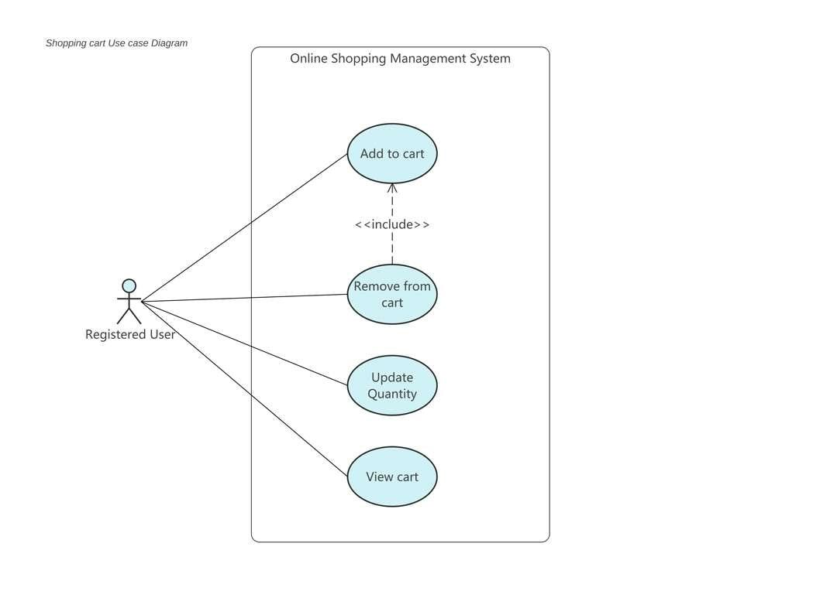 Figure 1: System Level Use Case Diagram
This diagram shows the interaction between the Customer and Admin with the system. The customer can register, login, browse products, add to cart, and place orders. The admin can manage products and orders.

  - Use Case 1
ID | UC001
Name | Sign Up
Description | This use case describes the process flow of Sing Up
Requirement(s) | FR001
Actor(s) | Admin, Data Entry, Operator
Precondition | Actors must not be member of Hospital
Postcondition | Actors will view the message for approval from admin
Basic Flow | Basic Flow  - Actor enter credentials  - System validates the inputs  - Following fields are required  - Name  - Email  - Password  - Address  - Phone  - Check the proper inputs for following  - Email  - Password must be 8 character including number  - Phone Number on 11 digits  - On successful validation the system will create new user  Alternative Flow  - Admin Sign In  - Create a new User by entering data  Exceptions  - Invalid Inputs  - System unable to response

Diagrams
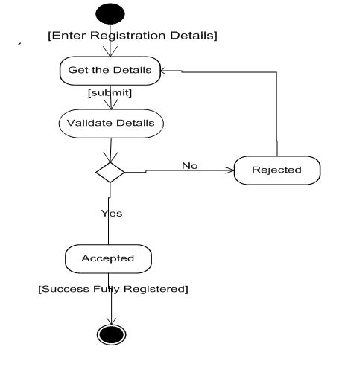
Case 1 Diagrams:
